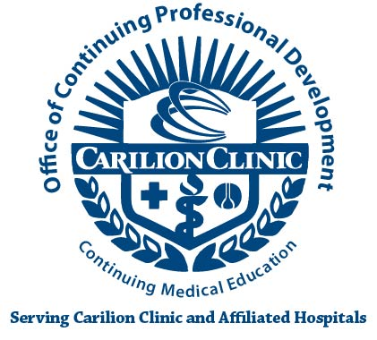
AGREEMENT OF COMMERCIAL SUPPORT FOR CONTINUING MEDICAL EDUCATION

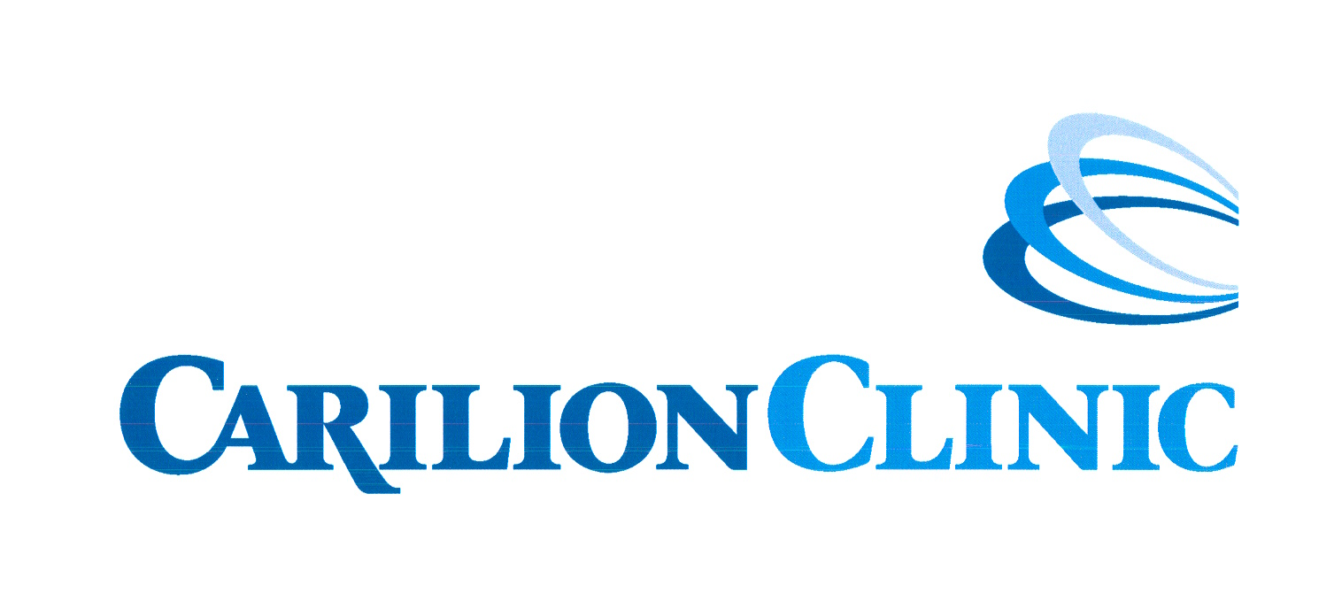

Terms, Conditions and Purposes of an Educational Grant for a jointly provided CME Activity
Between

Carilion Clinic’s Continuing Medical Education Program
and

(company)

Address
City, State, Zip Contact Person Title
Phone # FAX# E-mail
Title of CME Activity Location Date(s)

The above company wishes to provide support for the named continuing medical education activity by means of:

Educational Grant in the amount of: $

In-Kind Support:

Any commercial support received must be paid directly to the CME provider or CME Program.

The Commercial Supporter agrees to abide by all requirements of the ACCME standards for Commercial Support of Continuing Medical Education.
The Accredited Sponsor agrees to: 1) abide by the ACCME Standards for Commercial Support of Continuing Medical Education; 2) acknowledge education support from the commercial company in program brochures, syllabi, and other program materials; and 3) upon request, furnish the commercial supporter a report concerning the expenditure of the funds provided.

AGREED

Commercial Company Representative___________________________________________
Signature Date______________
Educational Partner_________________________________________________________
Signature Date _____________

CME Dept. Director or Designee__________________________________
CME Office Use Only

Signature____________________________ Date______________________

Revised 6/19

