One Health, One Voice for Antimicrobial Stewardship

**Tuesday, July 9th, 2024 | 8:30 AM – 1:00 PM**Carilion Roanoke Community Hospital – Medical building   
Community Room (400) – 4th Floor

**Target Audience:**

Physicians. Other healthcare professionals will also benefit from this educational opportunity.

**Conference Objectives:**

1. Contrast antimicrobial resistance data in animals to data from people in the same region
2. Apply antimicrobial use communication strategies to their area of medical practice
3. Compare antimicrobial stewardship recommendations across medical disciplines
4. Summarize the shared challenges and unique differences in antimicrobial stewardship implementation across human and veterinary medical disciplines
5. Explain how antimicrobial resistance and stewardship in your discipline affects healthcare delivery in other fields
6. Select antimicrobial stewardship practices to implement in your medical discipline

**Agenda:**

See the other side of this flyer for the complete agenda, speakers/affiliations

**Registration Information:**

Go to **https://redcapweb.carilionclinic.org/redcap/surveys/?s=H3L8XY9APJWAR3XM** or scan QR code to register  
NOTE: Registration is free. Due to the Stark Law, ***AMA PRA Category 1 Credit™*** will be provided to Carilion Clinic healthcare professionals only. (Stark Law is a set of United States federal laws that prohibit self-referral, specifically a referral by a physician of a Medicare or Medicaid patient to an entity for the provision of designated health services (“DHS”) if the physician or an immediate family member has a financial relationship with that entity).

**CME Credits:**

The Medical Society of Virginia is a member of the Southern States CME Collaborative, an ACCME recognized accreditor. This activity has been planned and implemented in accordance with the accreditation requirements and policies of the Southern States CME Collaborative (SSCC) through the joint providership of Carilion Clinic’s CME Program and Carilion Clinic Infectious Diseases. Carilion Clinic’s CME Program is accredited by the SSCC to provide continuing medical education for physicians. Carilion Clinic’s CME Program designates this live activity for a maximum of 2.67 ***AMA PRA Category 1 Credits™***. Physicians should claim only the credit commensurate with the extent of their participation in the activity.

**For More Information: (PLACEHOLDER)**

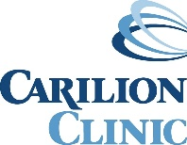

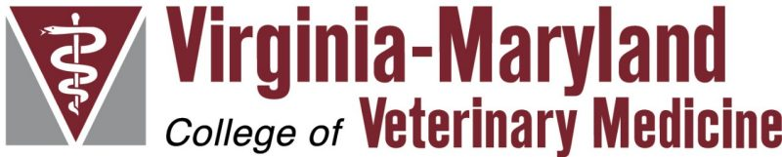

**One Health, One Voice for Antimicrobial Stewardship**

**Carilion Roanoke Community Hospital, Room 400 July 9th, 2024: 8:30am – 1:00pm**

|  |  |
| --- | --- |
| 8:30 – 9:00 | Registration, coffee and light breakfast |
| 9:00 – 9:10 | **Call to order and welcome address**  Dr. Anthony Baffoe-Bonnie, Section Chief of Infectious Diseases Service and Medical  Director of the Infection Prevention and Control Department at Carilion Clinic |
| 9:10 – 9:20 | **Perspectives on a One Health approach to antimicrobial resistance**  Dr. Cassidy Rist, Associate Director, Center for Public and Corporate Veterinary  Medicine, Virginia Maryland College of Veterinary Medicine |
| 9:20 – 9:50 | **Do people and pets share antimicrobial-resistant pathogens in southwestern Virginia?**  Dr. Tessa LeCuyer, Veterinary Clinical Microbiologist, School of Veterinary Medicine, University of California Davis  Dr. Jay Rao, Associate Professor, Department of Infectious Disease, Carilion Clinic  Dr. Rick Jensen, Department of Biological Sciences, Virginia Tech |
| 9:50 – 10:10 | **Public health priorities for antimicrobial stewardship in Virginia**  Dr. Shaina Bernard, Antimicrobial Resistance Coordinator for the Virginia Department of Health |
| 10:10 – 10:30 | **Veterinary profession priorities for antimicrobial stewardship**  Dr. Cooper Brookshire, Assistant Clinical Professor, Mississippi State University  At-large member of the American Veterinary Medical Association’s Committee on Antimicrobials |
| 10:30 – 10:40 | **Break** |
| 10:40 – 11:00 | **Educational activities to support One Health, One Voice for AMS in Virginia**  Dr. Cassidy Rist, Associate Director, Center for Public and Corporate Veterinary  Medicine, Virginia Maryland College of Veterinary Medicine |
| 11:00 – 12:00 | **One Health, One Voice Antimicrobial Stewardship panel discussion Session moderator: Dr. Cassidy Rist Panelists:**  Dr. Shaina Bernard, Antimicrobial Resistance Coordinator for the Virginia Department of Health  Dr. Cooper Brookshire, Assistant Clinical Professor, Mississippi State University  Dr. Bobbi Connor, Clinical Associate Professor, Emergency and Critical Care Medicine,  VMCVM  Dr. Michael Nappier, Clinical Associate Professor, Community Practice, VMCVM  Dr. Richard Bryant, Veterinarian and Owner, Salem Animal Hospital, Salem, VA  Dr. Ryan Fulton, Pediatrician, Carilion Children’s, Daleville, VA |
| 12:00 - 1:00 | **Lunch** |